**OBSERVATION REPORT**

**Log 1 - Vendor Lead Screw Profile Measurements**

Dated: 12-01-2021

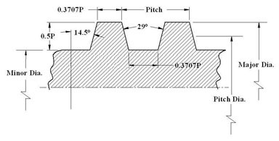

Let,

**D** = Diameter

**P** = Pitch

**T** = Teeth Length = 0.3707P

**t** = Teeth Gap Length = P – T

**h** = Teeth depth = 0.5P

*Fig. 1 - External ACME Thread Profile* [1]

**MEASURING JIG**

For finding the depth of cut in the lead screw, it is necessary to measure by

means of CMM or a custom jig. Here is a simplified experimental version L01-X3

of Lead Screw Depth of Cut Measuring Jig.

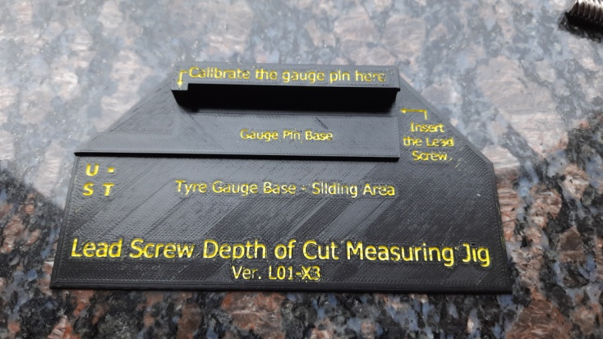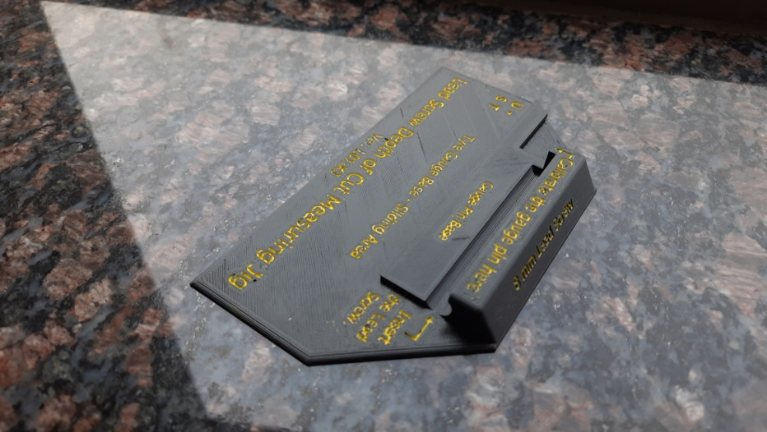

***Fig. 2 & 3*** *- Measuring jig top view and isometric view.*

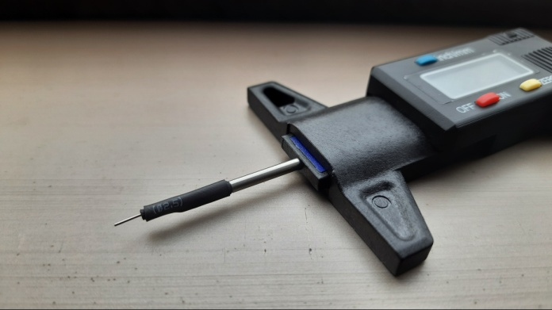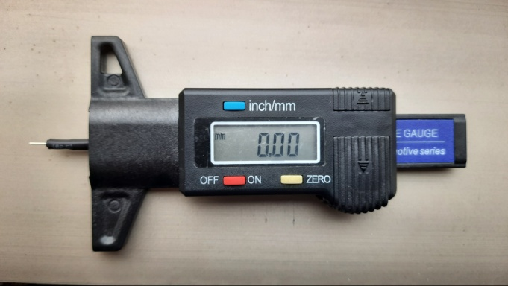

***Fig. 4 & 5*** *– Modified Tyre Gauge* [2]

In existing gauge, the (probe) pin diameter is to large, so that LED leg sealed by

Heat sink tube, such that this leg pin will enter through the depth of cut of lead

screw.

**PROCEDURE FOLLOWED**

**Step 1:** For the defining each lead screw of specific vendor, here we used masking tape

for labelling and coined as 3D1, 3D2, so on and IG1.

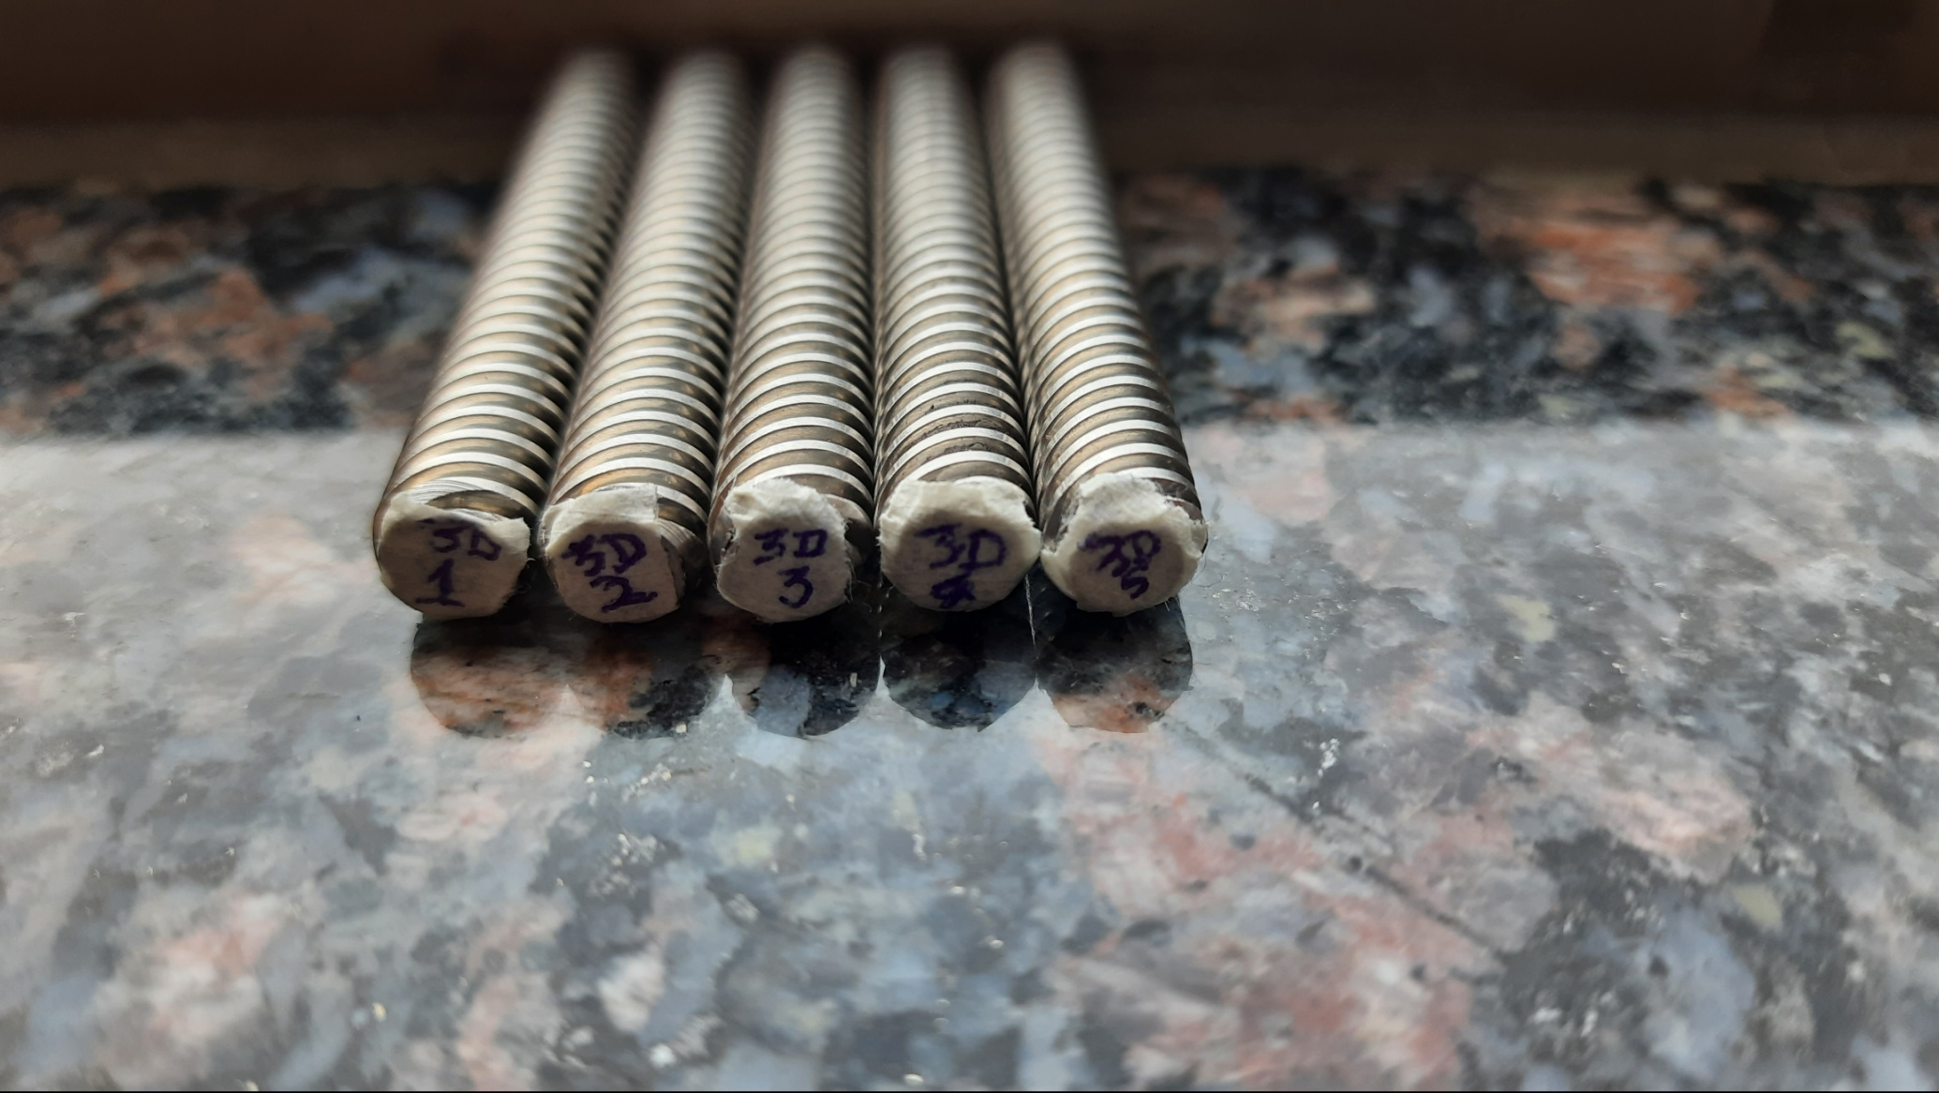

***Fig. 6*** *– Labelled lead screw of 3dPrintronics*

**Step 2:** Initially the gauge to be set zero by sliding to and fro over the outer area of the lead screw.

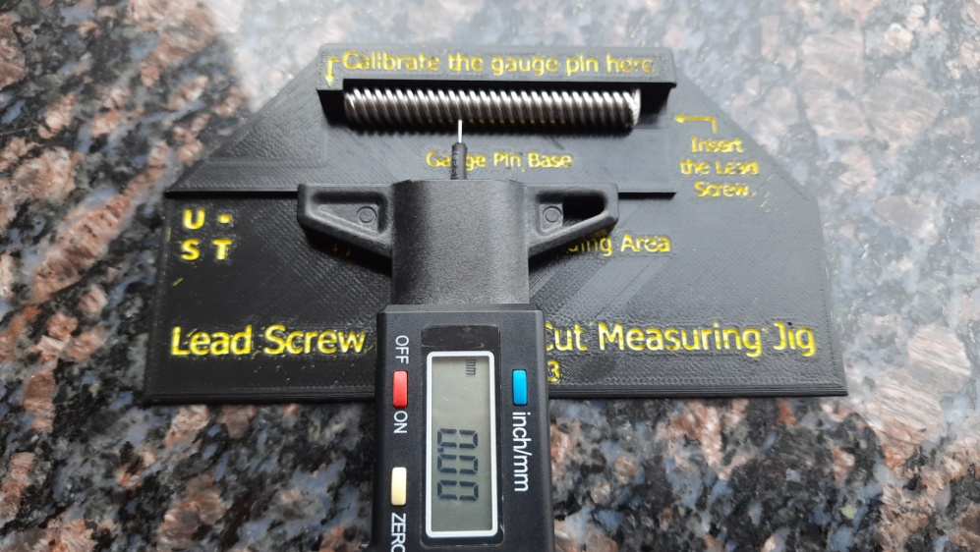

***Fig. 7*** *– Setting the value to zero over the circumference.*

**Step 3:** Inserting inside the depth will get to know the teeth depth **h** value and this has to be taken randomly

about 5 times or more.

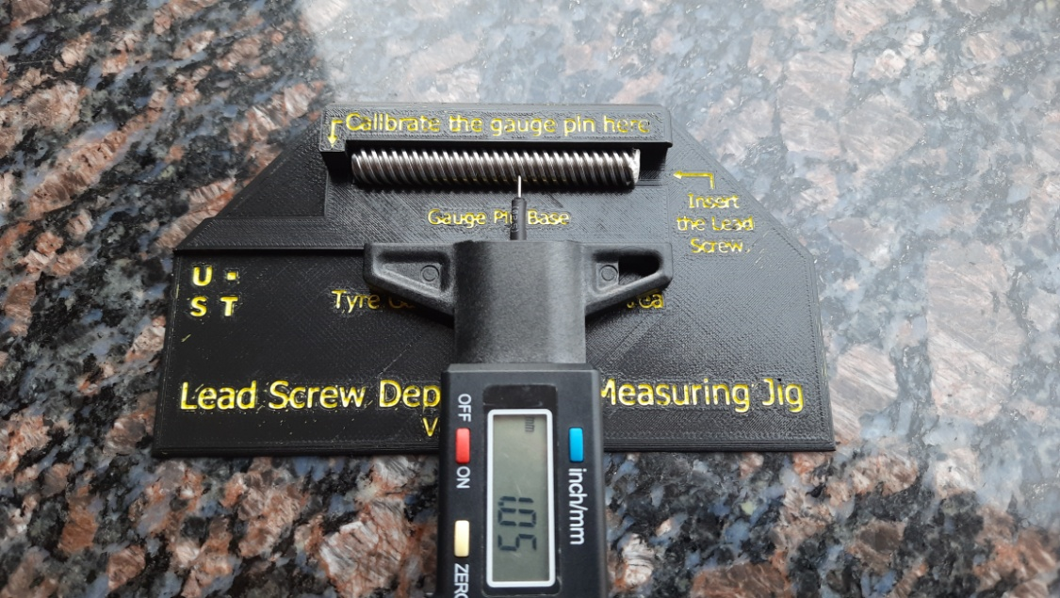

***Fig. 8*** *– Average value of depth* ***h***

**OBSERVATION TABLE**

|  |  |  |  |  |  |  |  |
| --- | --- | --- | --- | --- | --- | --- | --- |
| **General Details** | | | **Vernier Reading** | | | | **Tyre Gauge Reading** |
| Sl.no. | Vendor | Start | Diameter  **D** | Pitch  **P** | Teeth Len. **T** | Gap Len. **t** | Teeth depth  **h** |
| 3D1 | 3dPrintronics | 4 | 7.97 | 2.00 | 0.95 | 1.15 | 1.03 |
| 3D2 | 3dPrintronics | 4 | 7.96 | 2.10 | 0.90 | 1.20 | 0.99 |
| 3D3 | 3dPrintronics | 4 | 7.96 | 2.10 | 0.90 | 1.20 | 1.02 |
| 3D3 | 3dPrintronics | 4 | 7.96 | 2.20 | 0.85 | 1.30 | 1.05 |
| 3D3 | 3dPrintronics | 4 | 7.97 | 2.00 | 0.85 | 1.30 | 1.00 |
| IG1 | Igus | 1 | 7.93 | 1.50 | 0.70 | 0.80 | 0.85 |
| IG2 | Igus | 1 | 7.93 | 1.50 | 0.70 | 0.80 | 0.85 |

**RESULT/COMMENT**

* It is observed that slight variation occurs in the lead screws of each vendor and that is within the clearance value [3] a = 0.15mm for 8mm lead screw.
* Since each vendor is manufacturing on their dimensions, it is good to design acme nut by ourself using the observation data that obtained here.
* There is no assurance where the lead screw is acme or trapezoidal, that we need to find.

**REFERENCES**

1. Image Courtesy by <https://www.engineersedge.com/hardware/external_acme_thread_13360.htm>

2. <https://www.amazon.in/Preciva-Tread-Depth-Gauge-Digital/dp/B074KD2D73>

3. Central Machine Tool Institute (2017), **Machine Tool Design Handbook**, Page No. 106, 1st ed. Bangalore: McGraw Hill Education

**Report prepared by:** Mohammed Thousif and Johnson Ebenezer Rajendran